Family CARCHARHINIDAE Jordan & Evermann, 1896: Requiem sharks
Comments on the identification of Mediterranean species
THERE are presently nine carcharhinid species reported from Mediterranean waters, of which by far the most abundant being the blue shark Prionace glauca in offshore pelagic fisheries and sandbar shark Carcharhinus plumbeus typically represented in coastal fisheries, especially those of the southern-central Mediterranean, North Africa and Levant.
Others, primarily the spinner shark Carcharhinus brevipinna and (rather less frequently) the blacktip shark, Carcharhinus limbatus, may be encountered increasingly as one moves from Sicily and Tunisia south-easterly through the region's warmer zones towards Egypt and up towards Lebanon and the Aegean. In many respects, the status and distribution of both of these latter two sharks and other remaining species are poorly-known, primarily as most of these "grey" sharks appear outwardly similar and hence become collectively grouped as fisheries catch. There remain other well-known carcharhinids that have yet to be reliably reported from Mediterranean waters, such as the tiger Galeocerdo cuvier and bull Carcharhinus leucas sharks, yet in the past these species have been cited perhaps through misidentification with other similar species. The same argument equally applies to the wide-ranging, epipelagic oceanic whitetip shark Carcharhinus longimanus which - albeit known from eastern North Atlantic waters adjunct to the Mediterranean at Gibraltar - is yet to be reliably confirmed in the Mediterranean fauna. This writer considers such an addition highly likely, at least sporadically within the Alboran Sea, given the presence there of other pelagic Atlantic transients including Carcharhinus falciformis and Carcharhinus altimus.
Moreover, there remain difficulties in assessing occurrences as most regional requiem sharks share similar or identical colloquial names and are thus considered rather singularly by commercial fishermen. Prionace glauca is, however, readily identifiable and thus largely excludable from the discussion that follows.
To aid in identification, the carcharhinid sharks have been arranged in this guide firstly by reference to a primary diagnostic feature the presence or lack of an interdorsal ridge, which manifests itself as either a low or prominent dermal feature running longitudinally along the back, between the first and second dorsal fins. Identification points are then subdivided by features including the position of first dorsal fin compared to pectoral fin; markings on fin apices and so-forth as simplified below. If required, fuller morphometrical descriptions are given by Garrick (1982) and / or Compagno (FAO Fisheries Synopsis, Sharks of the World, 1984 [Part 2], of which a contemporary version is soon to be re-published) and Compagno's (1988, Princeton University Press) dedicated tome on the Carcharhinids.
DIAGNOSIS:
CARCHARHINID (REQUIEM) SHARKS OF THE MEDITERRANEAN SEA
1. Interdorsal ridge present: either Carcharhinus altimus, Carcharhinus falciformis, Carcharhinus obscurus or Carcharhinus plumbeus.
• If 1st dorsal origin over or nearer to pectoral insertions rather than free tips either = Carcharhinus altimus (relatively rare other than off Algeria) or Carcharhinus plumbeus (common or moderately common; widely distributed)
• Anterior nasal flaps prominent and triangular; interdorsal ridge high; distance from nostrils to mouth measures under 2.4 x in mouth width = C. altimus, Bignose shark. | • Anterior nasal flaps not prominent; interdorsal ridge low; first dorsal fin very high and sail-like; nostrils to mouth distance more than 2.4x in mouth width = C. plumbeus, Sandbar shark
• If 1st dorsal origin above or nearer to pectoral free tips rather than insertions = Carcharhinus obscurus, Dusky shark
• If 1st dorsal origin well behind pectoral free tips = Carcharhinus falciformis, Silky shark
2. Interdorsal ridge absent: either Prionace glauca, Carcharhinus brevipinna, Carcharhinus limbatus, Carcharhinus melanopterus or Carcharhinus brachyurus.
• Upper teeth with narrow, hooked serrated cusps; fresh (living) colour bronzy or golden-brown (1st dorsal origin over or just anterior to pectoral free tips) =  Carcharhinus brachyurus, Copper shark | • First dorsal fin base much nearer to pelvics than pectorals; fresh (living) dorsal colour is strikingly azure blue =  Prionace glauca, blue shark
• Fin apices conspicuously black-tipped:
(i) Always tipped, with white area below black tip of 1st dorsal =  Carcharhinus melanopterus, Blacktip reef shark | (ii) Usually tipped; 1st dorsal origin above pectoral insertion =  Carcharhinus limbatus, Blacktip shark | (iii) Usually tipped; 1st dorsal origin above pectoral free tips =  Carcharhinus brevipinna, Spinner shark
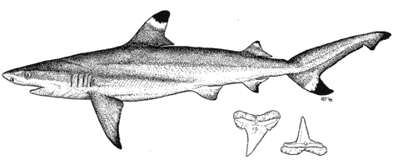
Carcharhinus melanopterus
Blacktip reef shark
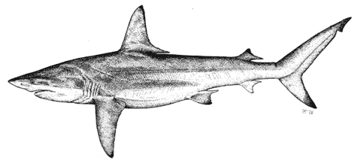
Carcharhinus limbatus
Blacktip shark
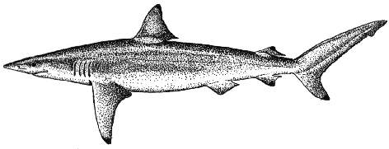
Carcharhinus brevipinna
Spinner shark
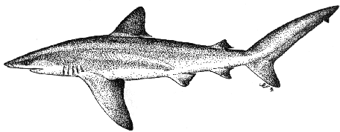
Carcharhinus altimus
Bignose shark
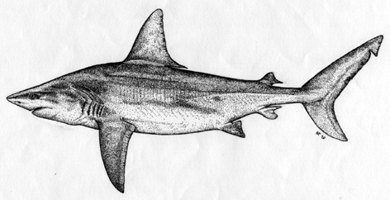
Carcharhinus plumbeus
Sandbar shark
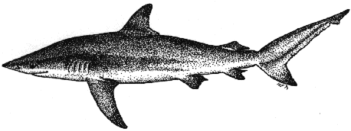
Carcharhinus obscurus
Dusky shark
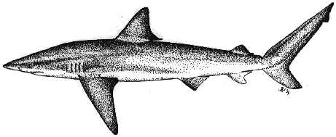
Carcharhinus brachyurus
Copper shark or bronze whaler
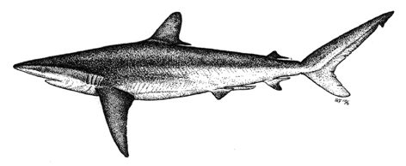
Carcharhinus falciformis
Silky shark
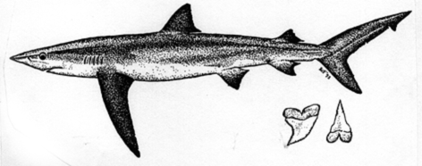
Prionace glauca
Blue shark

